“Creating Lives” Signature Assignment Project
HIST 1302
United States History II

  - Part I (200 words minimum) (Utilizing your course readings and materials, introduce your character in two or three paragraphs. Provide historically- accurate and meaningful details regarding your character’s name, date and place of birth, current place of residence, race, ethnicity, sex, gender, class, and other relevant personal detail and information. Each of these personal characteristics must be identified and explained. In addition, create an avatar (or some other artistic representation) of your character and explain why you chose the characteristics depicted. (COM)
Rodriguez Gonzales, a male Mexican-American, who now resides in Hill County, Texas, has a vivid memory of a wide range of his early childhood experiences, including major historical events: social, political, economic, and religious. Born in 1942 in Matamoros, a town approximately 20 mile from the present-day’s South Padre Island. Gonzales is a middle-class Mexican American, married to Grace Morales with five children, two boys and three girls. Unfortunately, Gonzales’ second child is crippled because she was attacked by an estranged Mexican neighbor in 1984. The attack, Gonzales admit, followed his decision to join the fight against the tyrannical Mexican leadership.

Gonzales’ Avatar
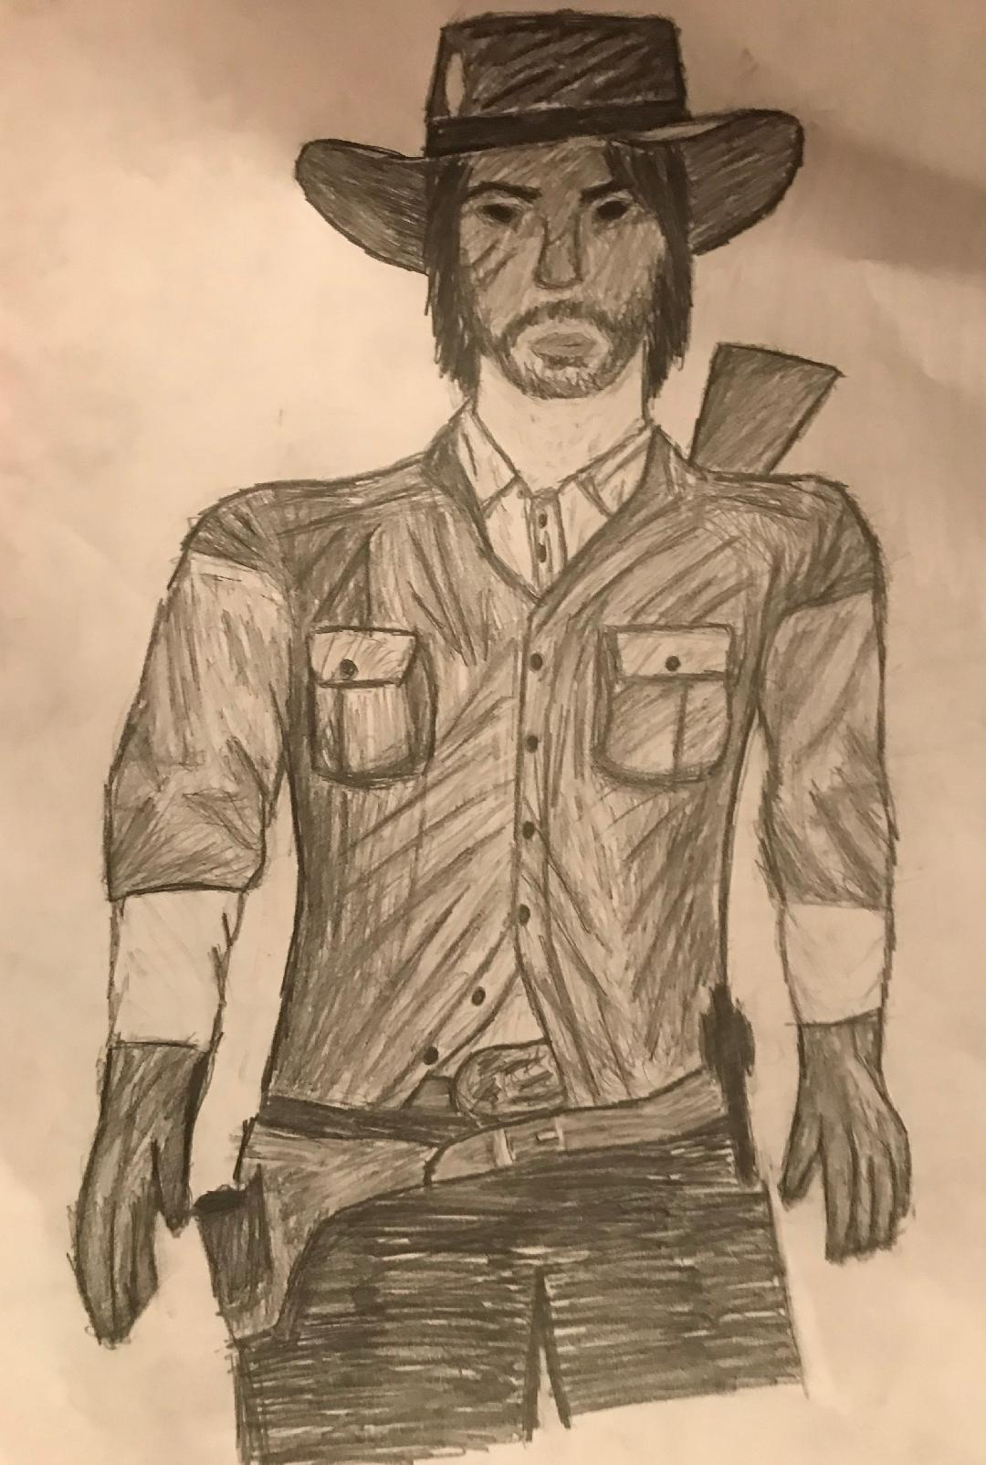
Characteristics. From the avatar, one can see that Gonzales is a well-muscled man. He has a knife and has two guns. This depicts his readiness and willingness to defend his family and ideals at all cost. Consequently, I have chosen to represent him this way because I believe he is confident, loving, and optimistic. Gonzales takes pride in his beliefs and other convictions as long as following them would result in freedom and the achievement of rewarding goals.
  - Part II (500 words minimum) (Analyze one of the major historic conflicts taking place in the time-period your character is living through (such as the Civil Rights movement, Vietnam War, Cold War, etc.) and is having a direct impact on the life of your character. Explain the historic antecedents or causes of such events. Be sure to identify the major historical figures and organizations that are associated with this event and the specific role(s) each played. Be sure to identify precise historical, social, political, economic, cultural, and global forces that shaped the event or conflict you are describing. Last, explain how this historical event or conflict affected or, perhaps, divided, Americans living in this era. (SLO1; SLO2, SLO3; CT; COM)
Gonzales and his family moved approximately one year before the American-Mexican border was closed off by the Mexican government. The decision in question was meant to prevent the entry of additional immigrants. This act went a long way in creating a great deal of uproar among Texans. Most importantly, this was not the only issue individual Mexicans had with Mexico. During this time, the stringent and partly oppressive Mexican government adopted stricter engagement and business regulations, imposing considerably high tariffs and taxes on American goods and services. Moreover, the people were being compelled to convert to or identify with Catholicism lest they face prosecution. Texans were denied the right to self-determination, with the government banning any new forms of slavery. In particular, blocking the Texans’ desire to become an independent state angered the people in Texas, but they did not initiate war, considering it a risky affair.
While Texans failed to take drastic actions that would lead to an all-out war, the first battle had already broken out at Gonzalez. Up to now, Mexico had lost only one of its soldiers. Despite the insignificant loss in the event of a small-scale war, the incident served as a major trigger massive rebellion against the Mexican President, Santa Anna. The people considered Anna to be one of the unpopular presidents because he paid little to no attention to the citizens’ desires and demands. For instance, his decision to end a constitutional reign made him a dictator, something that led to the withdrawal of Texans’ support base. Additionally, Anna made it public that his troops are ready to quiet rebellion among Texans. Consequently, residents in Texas realized the urgent need for the future state’s own soldiers for defense purposes. Being a highly-regarded individual and kind of a public figure because of his honesty and an exceptionally skilled hunter, Gonzales was chosen by Texans to lead one division of infantry.
Gonzales received the decision to serve as an infantry’s leader with shock, with his mind staying in constant processing of what he should do. While he witnessed the grievances the people had against the current Mexican authorities, he has never been too concerned about the socioeconomic, religious, and political issue as did most others in his circle. This explains the division that was witnessed among Americans who lived in this era. Following their arrival in Texas, Gonzales and his family had become Catholics. At the same time, he understood the reason for closing off more immigrants: coastal lands were increasingly becoming scarce. He however knew that that the sudden switch from a democratic system of governance to a tyrannical leadership would play a central role in destroying the peace in Texas. President’ Anna’s dictatorship was an existing threat to the land between the U.S. and Mexico itself, spurring the majority of Texans to want to engage in a direct conflict. The leading agitators for change included the War Party, settlers who occupied Mexican Texas, including Jose Antonia Navarro, who is remembered for signing the Texas Declaration of Independence.

  - Part III (200 words minimum) (Find and analyze one primary source document directly related to the historical event or conflict you described in Part II. Explain the historical issue or issues raised in the primary source document. In other words, what does the document tell us and what insights does it shed on the historical event you discussed in Part II? In your review of this primary source, explain the view or perspective of the author of the document. What is the overall purpose of the document? Last, provide at least three examples or quotes from your document that help you understand the perspective of the person(s) who produced it. Last, consider how the issues raised in the primary-source document you analyzed would have reinforced or challenged your character’s worldview, ethical values, and/or historical perspective. Would your character agree or disagree with the view or perspective expressed by this document? Be sure you properly cite the source you use. (SLO2; CT; COM)

In a recent article. “Does South Dallas need City Hall to save it? Does anybody?” published by Jim Schutze in Dallas Observer, the author addresses the issue of land and home ownership in West and South Dallas. In particular, the article discusses the causes of tension between Texans of different ethnic and racial backgrounds in these neighborhoods, arguing that the influx of Mexicans is seen by other races as a threat to their survival. While there is a rising tension in West Dallas and South Dallas, the author acknowledges and appreciates the fact this socioeconomic problem can be traced back to the Mexican War.
The conflict started when President Anna declared himself a dictator, in addition to making several attempts at denying Texans their right to self-determination. Schutze (2019) describes Mexicans as hardworking and good planners because they use the little they earn to purchase homes for their families members, a trait that he says is missing among the majority of blacks, thus the tension. Consequently, the primary purpose of this document or article is to illuminate the role played by Mexican immigrants in causing economic, social, and political tension in Texas and the rest of the U.S. In the author’s worldview, while blacks and Hispanics went through unbelievable tribulations, the latter are proving to be more aggressive in their economic quest. Briefly speaking, the following three quotes express Schutze’s perspective:
“Working people building a stable community and boosting the whole economy.”
“The arrival of hardworking law-abiding people who pay their mortgages and keep to themselves will gradually render a neighborhood less scary.”
“The Hispanic community, whether it’s legal or illegal, is the basis for a stable Texas economy.”
I firmly believe that the author’s sentiments would have played a fundamental role in reinforcing Gonzales’ worldview because he valued hard work and protection of his family. He understood that land was fast becoming sparse and it would come a time when homeownership in Texas would require doing exceptionally well in the state’s economy. Therefore, Gonzales would agree with Schutze’s opinions on the Mexicanization of South Dallas and West Dallas.

  - Part IV (200 words minimum): Identify one major historically relevant ethical dilemma or moral choice that your character is struggling with in regards to this historical conflict. What personal or unique impact is this historical event having on your character? Be sure to explain how this ethical issue relates to this historical event and how the event is directly affecting your character (i.e., impacting his or her everyday experiences and/or challenging your character’s world and ethical view(s)). (SLO1; CT; COM)

The main ethical dilemma that faced Gonzales involves the decision to agree or disagree with the delegate’s decision to declare Texans’ stand on self-determination and possible revolution against Anna’s dictatorial rule. In essence, he had the challenge of weighing the benefits and risks or costs of going to war with the Mexican government. According to Gonzales knew that joining the movement against the Mexican authorities would have far-reaching negative effects on the country’s economic and social stability. War would mean more societal pressures, economic failure, and continued suspicion of neighbors or civil wars.
In addition to the identified worries, Gonzales knew that leading the fight would most likely result in his death, leaving his family without a support system. Given he was brought up in a peace loving family, the dilemma troubled him to the core. He imagined a situation in in which his wife would be widowed and possible her death, the only land available taken away, and Texans failing to achieve their objective of being an independent state. Further, he believed that the war would go against his Christian beliefs, while at the same time, destabilizing the country, making it more susceptible to any forms of future attacks. While he agreed with the delegates’ demand for constitutional change, he saw war as the last option because he had the ethical and social responsibility of providing for his family and protecting the future of his country.
  - Part V (200 words minimum): Explain how your character has decided to respond to the ethical dilemma at hand and why he or she responded in the way you identified. Explain how your character’s cultural background and historical setting (i.e. the historical, social, political, economic, cultural and global forces), and the broader conceptions of ethical behavior embedded within, shaped your character’s response. Consider at least one of the following: (1) your character’s conception(s) of civic responsibility; (2) your character’s understanding of the importance and role of the democratic process; (3) your character’s respect for social justice, fairness, and difference; (4) your character’s experiences with prejudice, racial or gender discrimination, and/or economic and social marginalization. (SLO3; SR; COM)

Gonzales decided to accept the people’s request to lead one of the infantry’s division. His wife, Morales, suggested that they leave. Although it would be considerably challenging to find enough money to purchase land, rent a home, or build a life outside their motherland, Morales saw it was a worthy cause because its benefits surpassed the cost of fighting for what they could find elsewhere. On the other hand, Gonzales’ cultural and social background shaped his decision to take the risk because one of the core values he identified with involved protecting his brothers. Joining others in the fight against a tyrannical regime would go a long way in securing the future of generations to come.
Among Hispanics, both nuclear and extended families constitute the most essential or important aspect of life. Consequently, the deciding and overriding though that fell upon Gonzales revolved around his conceptions of civic responsibility (Lee & Kawachi, 2019). While the decision to lead a war against the oppressive regime would be against his family values, Gonzales was convinced that liberating Texans comes before family. Texans’ freedom meant that his family and the larger lineage would be safer. Gonzales’ conceived civic responsibility as being liberal and patriotic. By revolting, he advocated a fair system of governance, and by choosing the safety of his countrymen, he was exercising his patriotism.
  - Part VI (200 words minimum): Last, explain how your character’s understanding of self and his or her related personal values influenced their response to the ethical dilemma faced and/or was altered by the historical events of the era he or she experienced. (PR; COM)
Like any other human being Gonzales has a unique primitive sense of what constitutes real self. According to Gonzales, his actions are a true reflection of his self. Before acting, he could look at and speak to himself in the mirror. In doing so, he was reassuring himself of the need to identify with and practice what is right, regardless of the outcome. This personal value manifested when he overcame his worries or doubts, as well as Morale’s discouragement, by joining the fight against the oppressive political system in Mexico. Gonzales’ staunch Christian values of service and endurance motivate him to break the boundaries set by strong family values as he prioritized Texans’ freedom and overall well-being to his wife and children (Lee & Kawachi, 2019). Moreover, his second-born suffered a crippling attack because of his stance, but all these did not deter him from solving the puzzle presented by the ethical dilemma of fighting or surrendering to the pressure. Equally important, Gonzales was driven by love and kindness because he believed in free and stable society characterized by peace.

References
Lee, M. & Kawachi, I. (2019).The keys to happiness: Associations between personal values regarding core life domains and happiness in South Korea. PLoS ONE, 14(1): e0209821. https://doi.org/10.1371/journal.pone.0209821
Schutze, J. Does South Dallas need City Hall to save it? Does anybody? Dallas Observer, Sep. 2, 2019. https://www.dallasobserver.com/news/in-a-cruel-land-war-in-south-dallas-whose-side-will-city-hall-take-11745134

